College of Arts and Sciences

Office of the Associate
and Assistant Deans

114 University Hall
230 North Oval Mall
Columbus, OH 43210

614-292-1667 Phone
asc.osu.edu

May 12th, 2025

W. Randy Smith, Vice Provost
Council on Academic Affairs
Bricker Hall
CAMPUS

Dear Randy:

I am pleased to endorse the proposal by the Department of Philosophy to create a certificate in Artificial Intelligence Ethics and Society, effective Autumn 2025. The Department of Philosophy will be responsible for overseeing the certificate. The is a Type 1a, 1b, and 2 certificate.

This certificate represents a coordinated effort in the college to provide students, especially (but not exclusively) those in the Arts and Humanities, an opportunity to supplement their major program of study with AI fluency. This is in response to both the fast-growing demand from employers to have students trained in AI and is in alignment with the goals of the university. This represents the first in a set of certificates on AI. The certificate does not duplicate any other currently offered at Ohio State. It has the full support of the College of Arts and Sciences.

Sincerely,

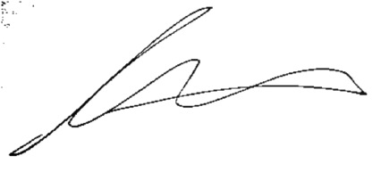

Andrew W. Martin
Associated Dean for Undergraduate Education
Professor, Department of Sociology

